### PREDICT HEART FAILURE USING IBM AUTO AI SERVICE

**Name: Dr.Valarmathi ,**

**School of Information Technology and Engineering**

**Vellore Institute of Technology, Vellore**

**Given Specification**

**Project Description:**

Cardiovascular diseases (CVDs) are the number 1 cause of death globally, taking an estimated 17.9 million lives each year, which accounts for 31% of all deaths worldwide.

Heart failure is a common event caused by CVDs and this dataset contains 9 features that can be used to predict mortality by heart failure.

In this project, you need to build a model using Auto AI and build a web application where we can get the prediction of heart failure.

**Services Used:**

* IBM Watson Studio
* IBM Watson Machine Learning
* Node-RED
* IBM Cloud Object Storage

**Architecture:**

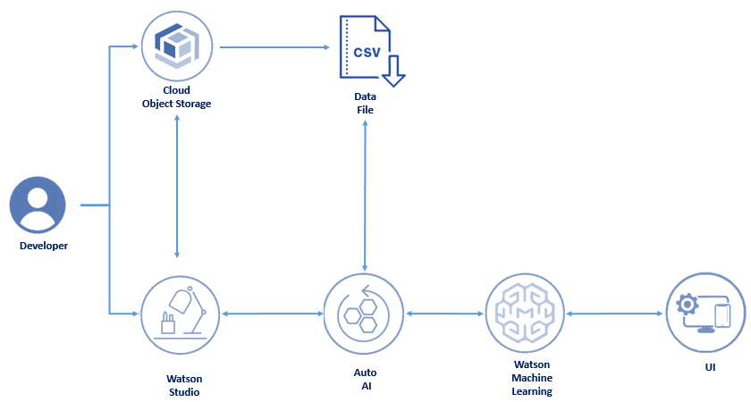

**Dataset Given:**

|  |  |  |  |  |  |  |  |  |  |  |
| --- | --- | --- | --- | --- | --- | --- | --- | --- | --- | --- |
|  |  |  |  |  |  |  |  |  |  | |
|  |  |  |  |  |  |  |  |  |  |  |

**AutoAI Experiment with Pipeline Comparison:**

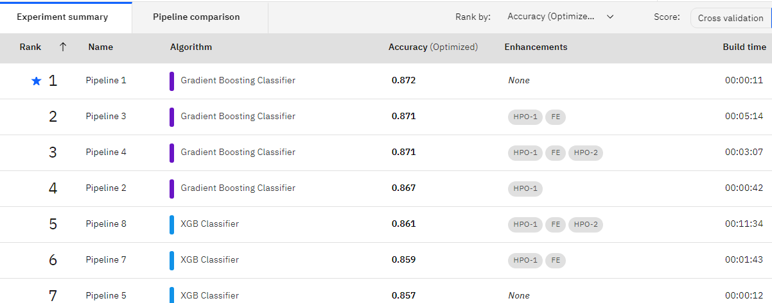

**Machine Learning Model Deployed in IBM Cloud:**

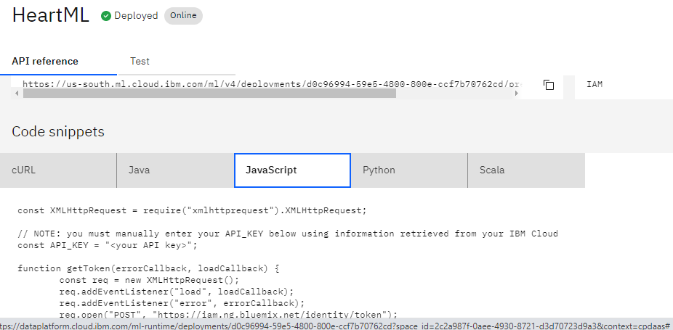

**Design of UI in Node Red**

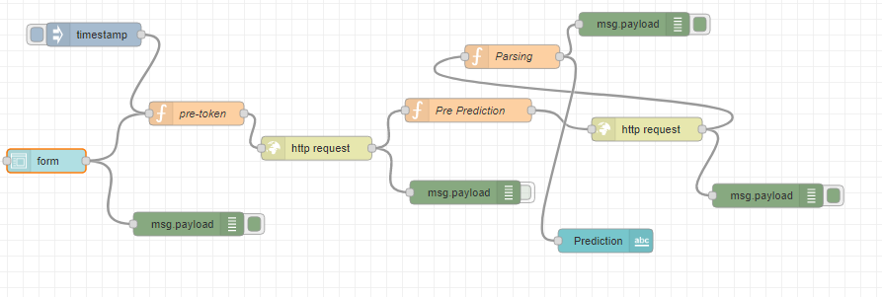

**Script at Pre_prediction:**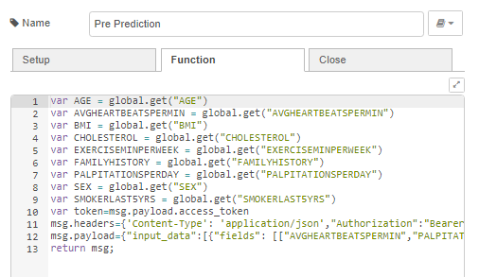

**Script at Node _Parsing**

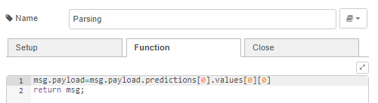

**Screenshot of the Web APP UI designed by Node Red with Input and Prediction:**

